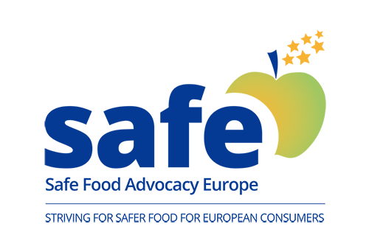
Internship Offer

SAFE is a non-profit independent organization based in Brussels whose goal is to ensure that consumers' health and concerns stay at the core of EU food legislation.
SAFE strengthens the voice of European consumers in civil society and contributes to the reinforcement of participatory democracy in Europe.
Please, visit our website: www.safefoodadvocacy.eu

We are looking for two dynamic, efficient and multi-skilled INTERNS to support SAFE in the role of “COMMUNICATIONS & EU AFFAIRS” for 6 months, starting in September 2018.

PROFILE & REQUIREMENTS
- Legal eligibility to work in the EU is a must;
- Strong research, editing, writing and proofreading skills;
- Be an independent, proactive, problem solver and team player person;
- Excellent English with strong communication skills (written and verbal), French is a plus;
- Bachelor’s degree or current student of European Affairs, Journalism, Political Science, Law or other related studies;
- Foreign students should be covered by the insurance from their home country.

MAIN FUNCTIONS AND RESPONSIBILITIES
- Monitor and provide analyses of EU food safety policies and legislations;
- Conduct research, prepare articles and publications, advertisements, presentations and press statements;
- Manage and update SAFE’s social media channels to inform consumers and share the latest activities and events.

WHAT WE OFFER
- You will be part of a small but dynamic and international team;
- You can play a key role in a growing organization located in Brussels and help bolster its reputation in the context of EU Institutions and Trade Associations;
- You will be given responsibilities to follow the EU Food legislation process;
- You will attend events and conferences at EU Institutions, NGOs and Social Platforms.

Qualified candidates should send their CV and cover letter to Chiara Granieri: euaffairs@safefoodadvocacy.eu

The internship is UNPAID, priority will be given to applicants who are part or are planning to apply for Erasmus Plus or other scholarship.

